User Manual

For

Integrated Grievance Redressal System

Developed For:
Uttar Pradesh Power Corporation Limited, Lucknow

Version 1.0

Submitted By : Designed & Developed By:

Table of Contents

1. Introduction 3
1.1 Overview 3
1.2 Scope of the Document 3
2. About the Document 3
2.1 Intended Audience 3
2.2 Document Convention 3
3. Process Flow 4
4. Getting Started 4
4.1 System Requirements 4
4.2 Accessing Portal 4
4.3 Integrated Grievance Redressal System Login Page - Customer 7
4.4 Dashboard –Customer 8
4.5 New Complaint 9
4.6 View Your Complaint 10
5. Dashboard 11
5.1 Pending Complaints 12
5.2 Forwarded Complaint 12
5.3 Rejected Complaint 13
5.4 Solved Complaint 13
5.5 Take Action 14
6. Dashboard - Admin 15
6.1 Register Complain 16
6.2 Manage Complain 16

Introduction

Overview
Integrated Grievance Redressal System for Uttar Pradesh Power Corporation is web based software application which is used to manage and monitor the grievance received online.

Scope of the Document
This document provides step by step guidance on how to use IGRS. Web Based Software Application for IGRS will have number of features associated with its account and they are as follows:
- The database will be centralized and will be stored on a central database server.
- The software will also have functionality to generate a unique ID for each complaint which will be based on meaningful algorithm.
- The system will be accessible online and will be accessible from any computer via internet connectivity.
- Consolidated reports will be generated by the software on the basis of input given by the user.

About the Document

Intended Audience
The registered user would be intended audience for this Integrated Grievance Redressal System for Uttar Pradesh Power Corporation Limited.

Document Convention
This User Manual has following conventions:
- Fields which have * sign at the end, indicates that it is mandatory.
- Error Messages will be displayed in Pop-up box.
- Success Messages will be displayed in Pop-up box.
- All the menu links will be mentioned in the side menu.

Process Flow
Given below is the Process Flow Diagram of Integrated Grievance Redressal System of UPPCL for better Understanding:

Getting Started

System Requirements
To run this application there are some basic requirements, as follows:
- Window’s Machine
- Firefox 30 or above /Chrome 32 or above
- MS Office (2007 or Above)
- Internet Connectivity (256 Kbps or above)

Accessing Portal
To access the portal, type the address in the address bar as: http://Uppcl.org/User will be redirected to the home page of the UPPCL Public Portal. Once user will click on the ‘Link (mentioned below in image)’ it will be navigated to the home page of Integrated Grievance Redressal System.
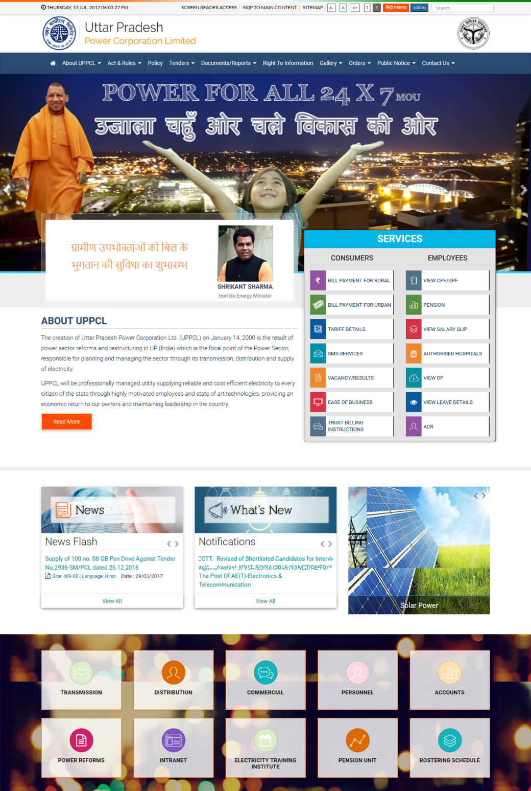
Click on the Link.
Image: UPPCLHome Page
- Click on the INTRANET link.
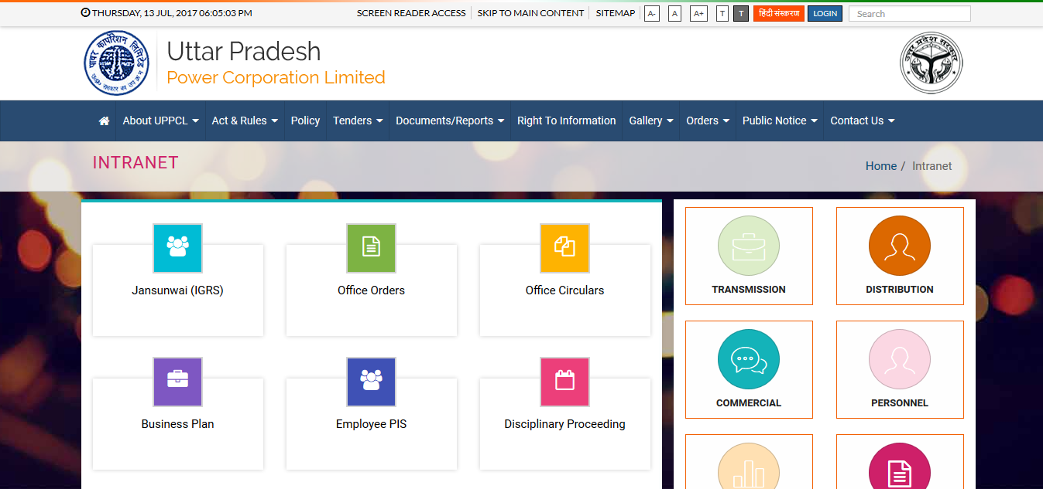
Click here.
Image: IGRS
- Click on the link as mentioned in the image then this page will be navigated to the Login page of Integrated Grievance Redressal System as shown below:
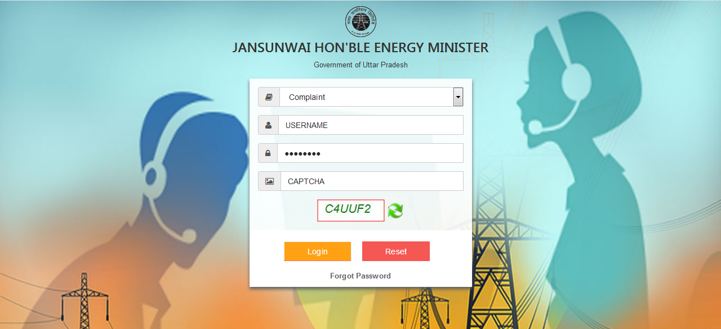
Fill all the details then click on Login button.
Image: IGRS – Login
- Fill all the details then click on Login button to get login

Integrated Grievance Redressal System Login Page - Customer
- This page provides access to Customer inside the Integrated Grievance Redressal System for UPPCL:

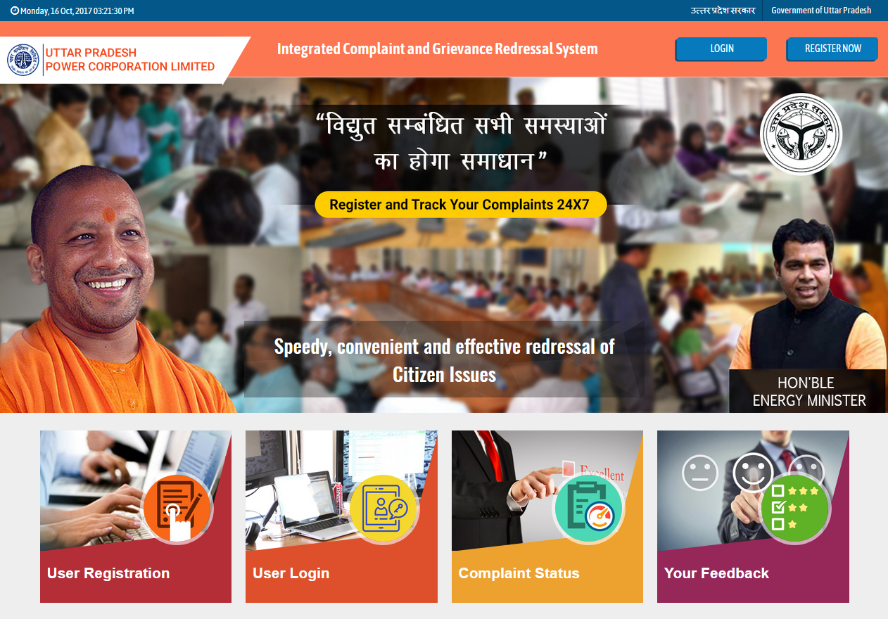
Click on Login button to login or click on Register Now button to register as new user.
Image: UPPCL - IGRS
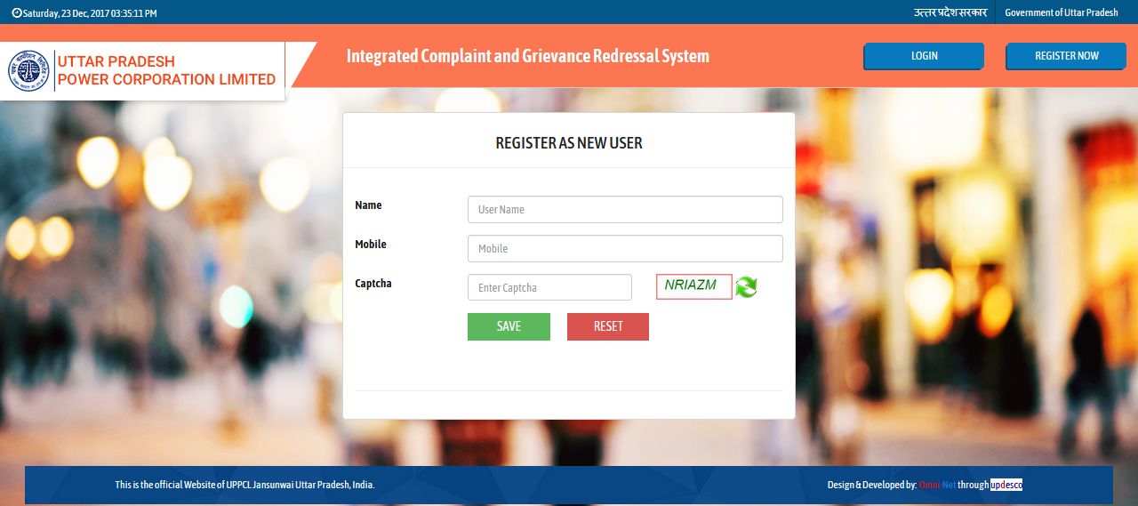
Fill all the details in the Register As New User form then click on Save button to create registration.
Image: IGRS – Register as New User
- Fill all the details then click on Save button to create the registration. All the details like username, password will be send to the provided Mobile Number and Email – ID.

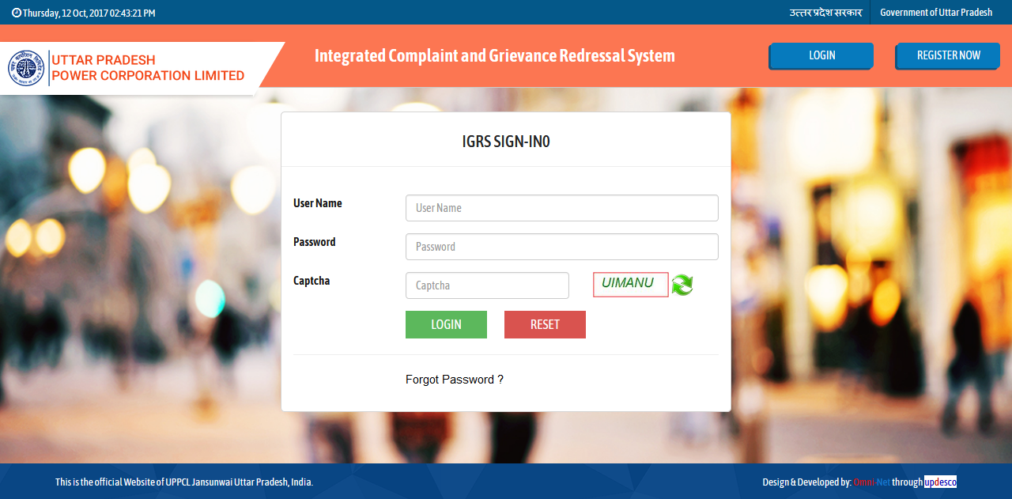Image: Integrated Grievance Redressal System Login page - Customer
Fill Username, Password and Captcha then click on Login button.
- Fill Username, Password and Captcha then click on Login button.

Dashboard –Customer
- Dashboard will be displayed as below:
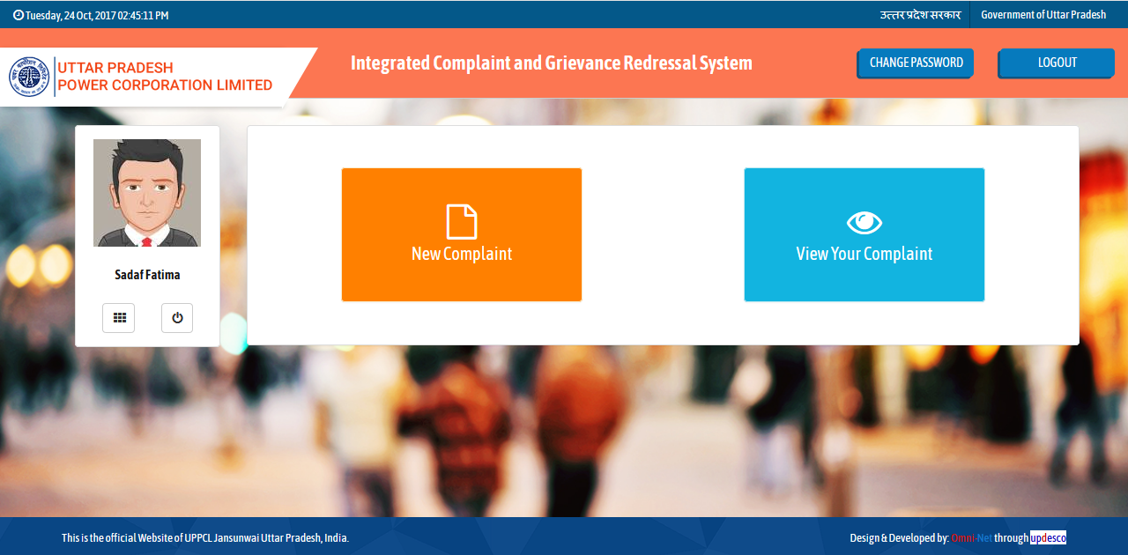Image: Dashboard - Customer
Click here to view your registered complaint.
Click here for New Complaint.
- Click on the New Complaint – Complaint Panel (for Complainant) button to add new complaint.

New Complaint
- New Complaint Screen will be displayed as below:
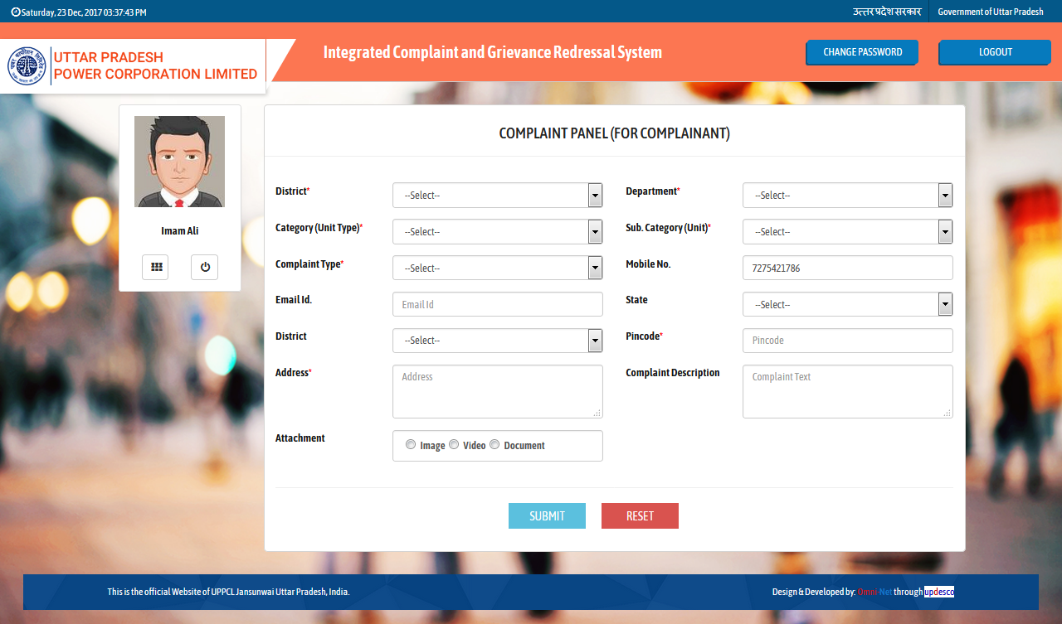Image: New Complaint
Fill all the details then click on Submit button.
- Step 1 - Fill all the details then click on Submit button.
- After clicking on the Submit button confirmation page will be displayed as shown below:
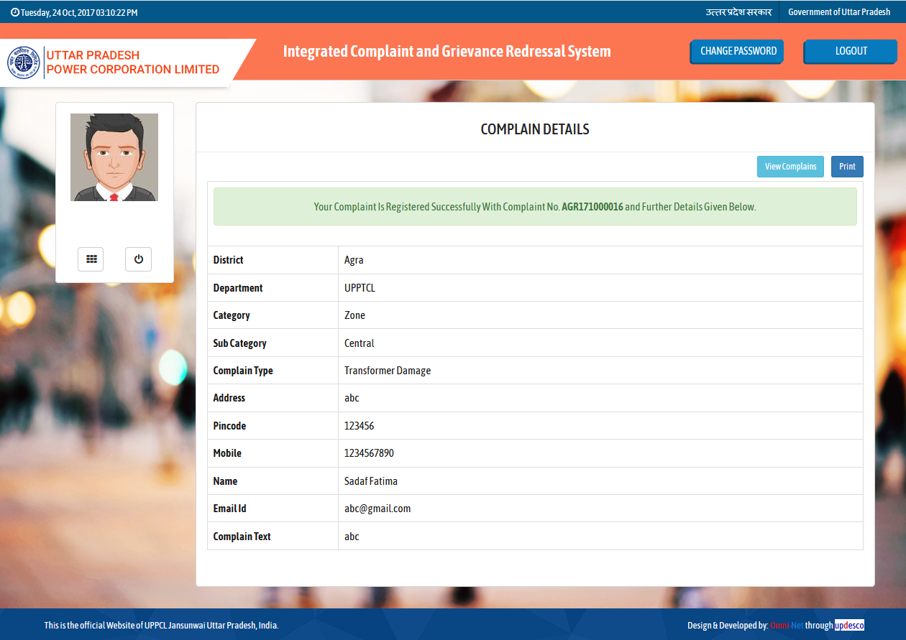
Click to move back to the dashboard.
Image: Complain Details

View Your Complaint
- Click on the View Your Complaints link on dashboardthen screen will be displayed as shown below :
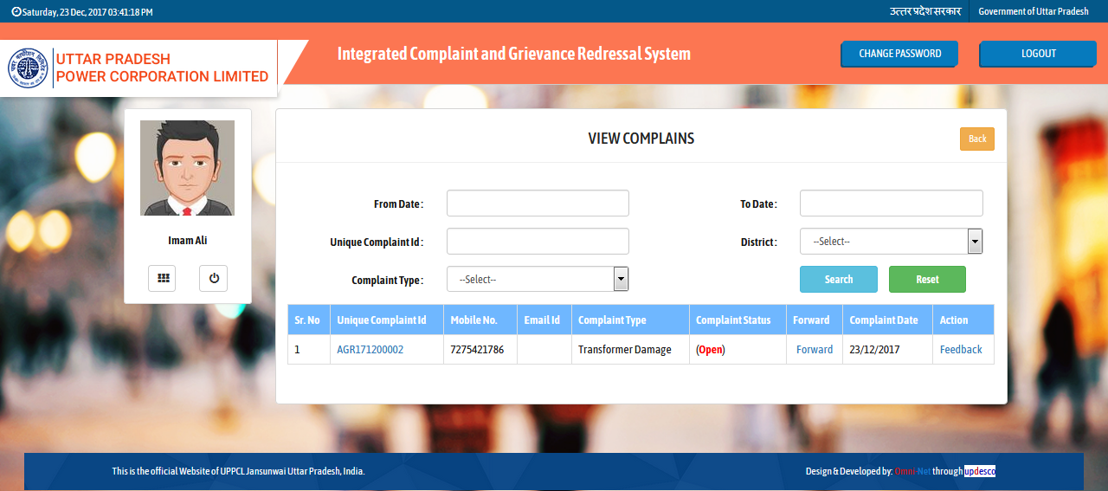
Click to give feedback.
Click here
Image: Manage Complaints
- Fill all the details then click on Search button to search or view the complaint.
- Click on feedback button to give feedback as shown below:

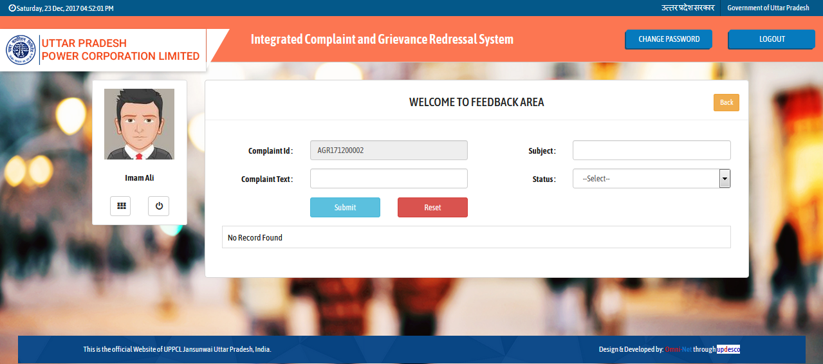
Fill all the details then click on Submit button.
Image: Feedback

- Fill all the details then click on Submit button.

Dashboard
- Discom, Zone, Circle, Division, Admin can login by the same login as mentioned above in point 4.2 then dashboard will be displayed as shown below :

Click on Admin tab.
Image: Dashboard
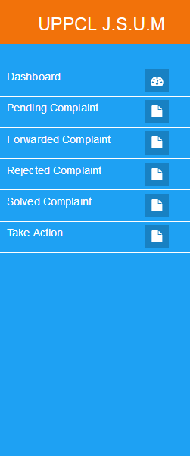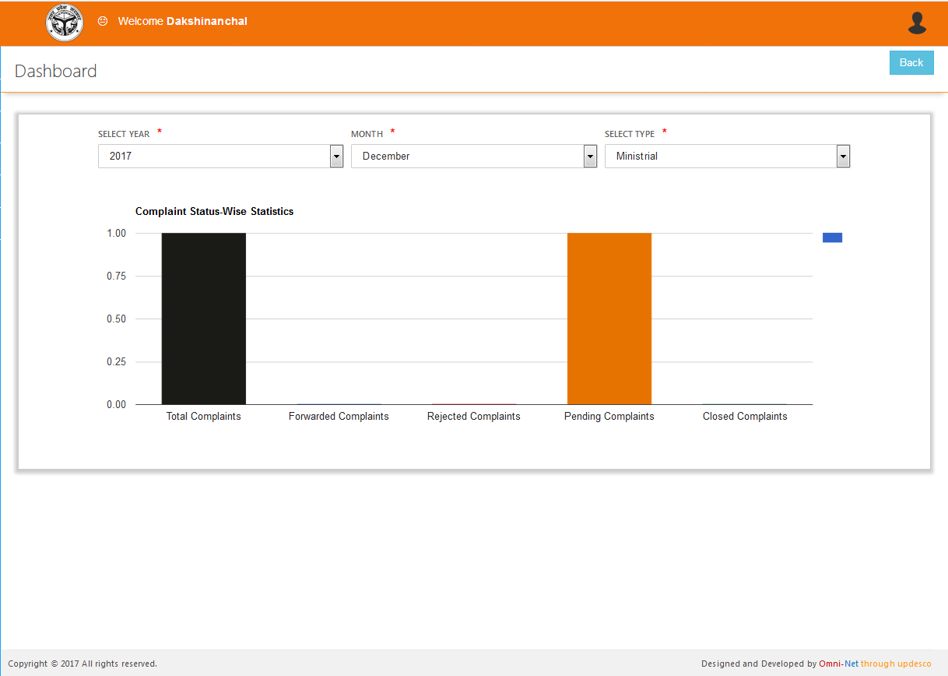Image: Dashboard
Select Year, Month and Type to see the graph details.
Click here.
- Select Year, Month and Type to see the Graph Details.
- Click on the Pending Complaint link as mentioned in the image to see the pending complaint details.

Pending Complaints
- Click on Pending Complaints tab on dashboard, screen will be displayed as shown below :
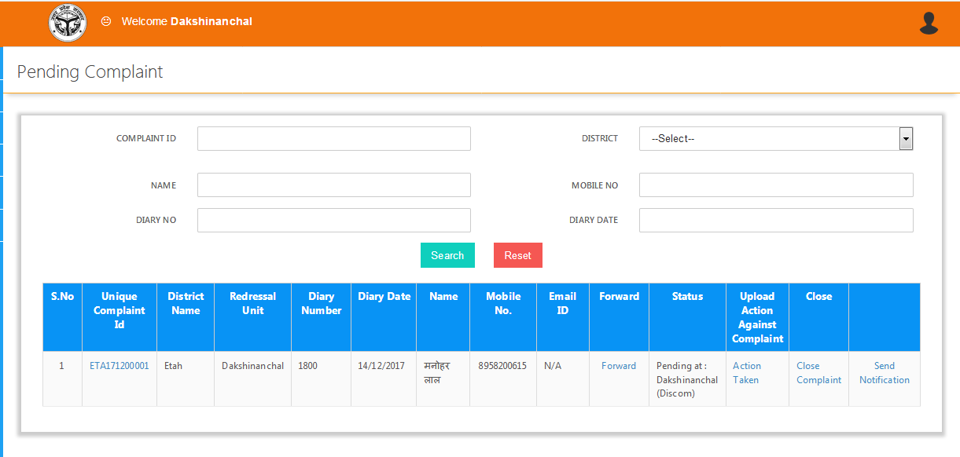 Image: Pending Complaints
Click on Forward, Action Taken, Close Complaint, Send Notification controls to use the particulars in the table
Fill all the details in the form then click on Search button.
- Fill all the details in the Pending Complaints form then click on Search button.
- Click on Forward, Action Taken, Close Complaint, Send Notification controls to use the particulars in the table.

Forwarded Complaint
- Click on Forwarded Complaint tab in dashboard, a screen will be displayed as below :
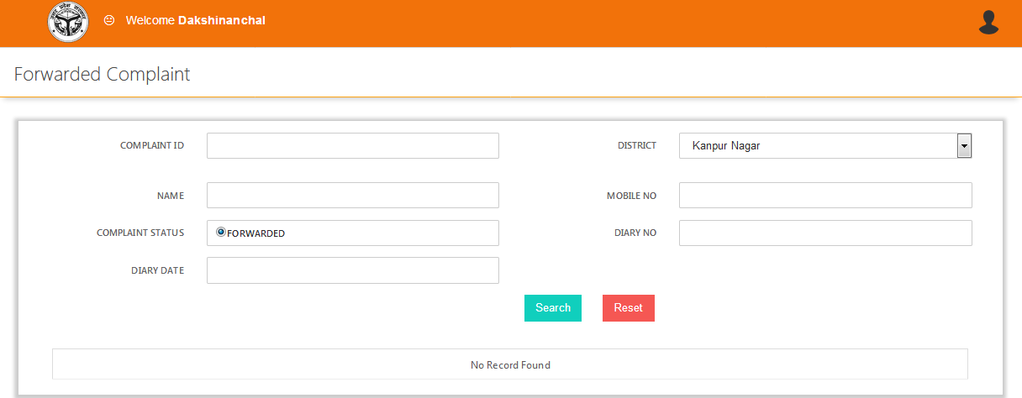
User can use controls like Close, Forwarded and Upload Action against Complain controls in the table.
To Search the complaint select and fill details then click on Search button.
Image: Forwarded Complaint
- Fill all the details then click on Search button.
- User can use controls like Complain Status, Close, Forwarded and Upload Action against Complain controls in the table.

Rejected Complaint
- Click on Rejected Complaint tab in dashboard, a screen will be displayed as below :
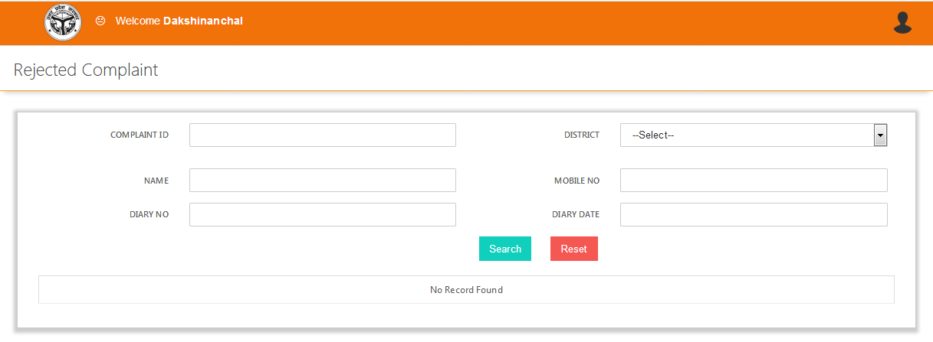
Click on Unique Complain ID to get the details about particular complain in the view table.
To Search the complaint select and fill parameter then click on Search button.
Image: Rejected Complaint
- Fill all the details then click on Search button.
- Click on Unique Complain ID to get the details about particular complain.
- Note: Complain can be reject at any level if the particular complain is not related (with reason) to particular level.

Solved Complaint
- Click on Solved Complaint tab in dashboard, a screen will be displayed as below :
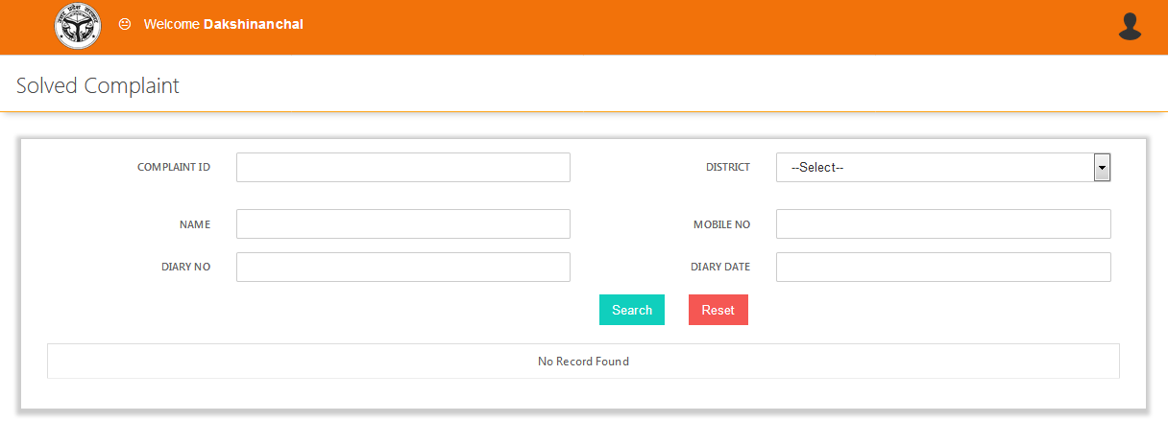
Click on Unique Complain ID to get the details about particular complain.
To Search the complaint select and fill parameters, then click on Search button.
Image: Solved Complaint
- Fill all the details then click on Search button.
- Click on Unique Complain ID to get the details about particular complain.

Take Action
- Click on Take Action tab in dashboard, a screen will be displayed as below :
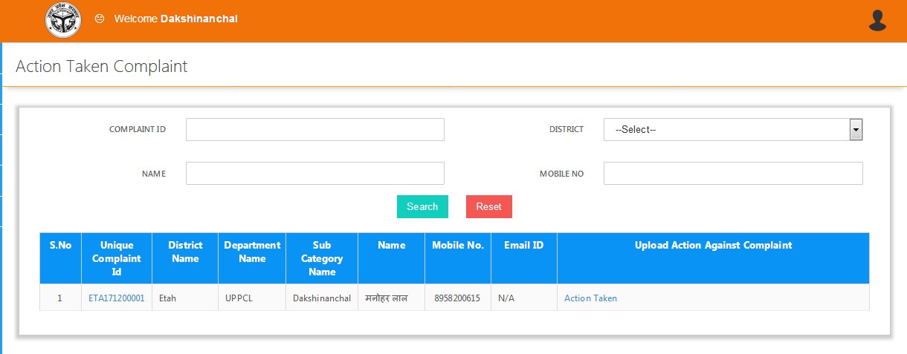
Click on Unique Complain ID to get the details about particular complain. Click on Action taken button to apply action on the complaint.
To Search the complaint select and fill parameters, then click on Search button.
Image: Take Action
- Fill all the details then click on Search button.
- Click on Unique Complain ID to get the details about particular complain.Click on Action taken button to apply action on the complaint.
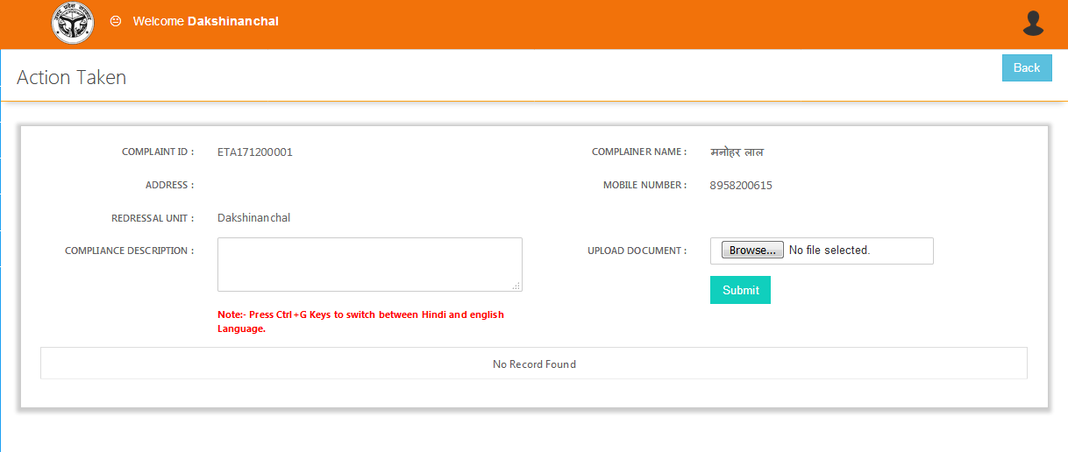
Fill all the details and upload the documents then click on Submit button to take action.
Image: Take Action
- Fill all the details and upload the documents then click on Submit button to take action.

Dashboard - Admin
- Admin can login as mentioned in point 4.2 and after successful process dashboard will be displayed as below :
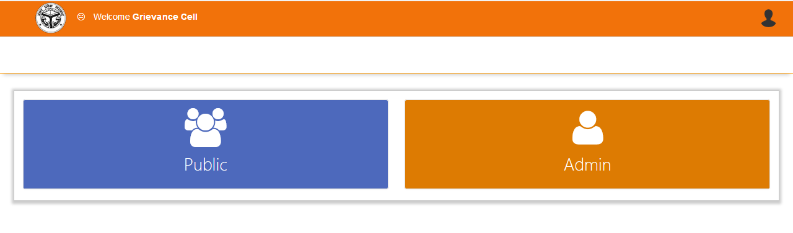
Click on Admin Tab to proceed.
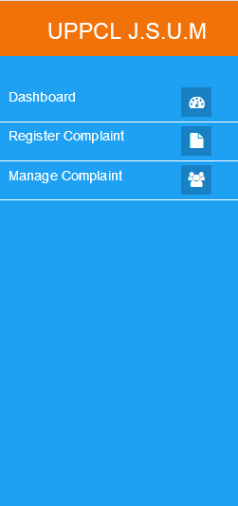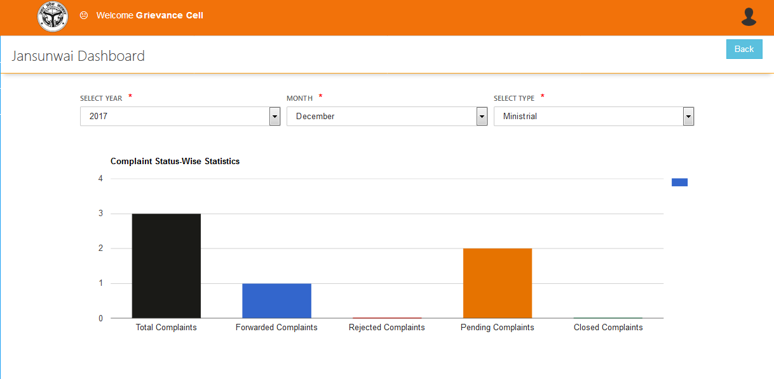
Click here.
Select Year, Month and Type to get the graphical details.
Image: Dashboard - Admin
- Click on the Register Complaint link as shown above.

Register Complain
- Complaint Panel will displayed as shown below:

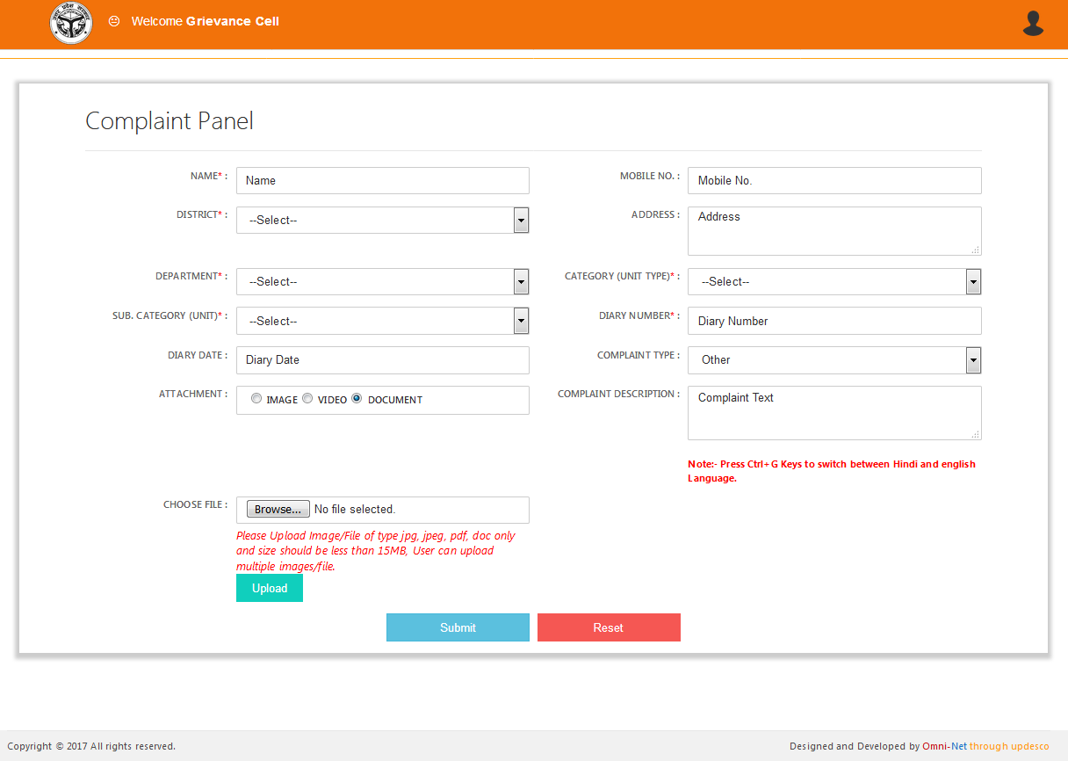
Fill and Select all the details and upload attachments then click on Submit button to submit complain.
Image: Register Complaint
- Fill and Select all the details and upload attachments then click on Submit button to submit complain.

Manage Complain
- Click on the Manage Complain link on the dashboard and screen will be displayed as shown below:
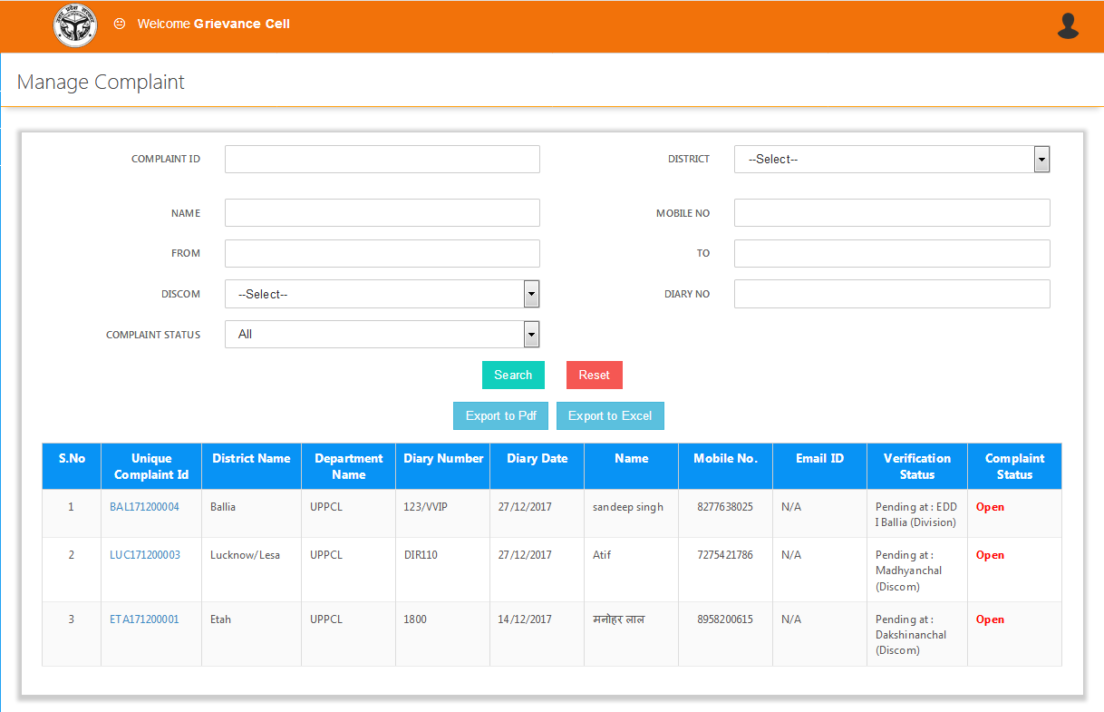
Fill all the details then click on Search button to search the details.
Click on Unique Complain ID to get the details about complain.
Image: Manage Complain
- Fill all the details then click on Search button to search the details.

